**Project Design Phase-II**

**Data Flow Diagram & User Stories**

|  |  |
| --- | --- |
| Date | 19 May 2023 |
| Team ID | NM2023TMID19358 |
| Project Name | Project - Gas Pipeline Monitoring System For Hospitals |

**Data Flow Diagrams:**

A Data Flow Diagram (DFD) is a traditional visual representation of the information flows within a system. A neat and clear DFD can depict the right amount of the system requirement graphically. It shows how data enters and leaves the system, what changes the information, and where data is stored.

**Example:** [**(Simplified)**](https://developer.ibm.com/patterns/visualize-unstructured-text/)

**User Stories**

Use the below template to list all the user stories for the product.

| **User Type** | **Functional Requirement (Epic)** | **User Story Number** | **User Story / Task** | **Acceptance criteria** | **Priority** | **Team Member** |
| --- | --- | --- | --- | --- | --- | --- |
| MOXA | **gas pipeline monitoring systems** for hospitals | USN-1 | The **system** consists of an LPG **gas** leakage detector which sends a warning signal to Arduino Uno Microcontroller. The **system** uses the GSM network ... | I  **ensured only when there is a proper upkeep and maintenance of the system**. | **The Area Control Unit monitors and controls medical gas and vacuum pressures** | Senisha.s  Aruljothi.s  Kabi.s  Divya.g |

**Project Design Phase-II**

**Solution Requirements (Functional & Non-functional)**

|  |  |
| --- | --- |
| Date | 19May 2023 |
| Team ID | NM2023TMID19358 |
| Project Name | Project - Gas Pipeline Monitoring System For Hospitals |

**Functional Requirements:**

Following are the functional requirements of the proposed solution.

|  |  |  |
| --- | --- | --- |
| **FR No.** | **Functional Requirement (Epic)** | **Sub Requirement (Story / Sub-Task)** |
| FR-1 | GPRS | Each BSC requires the installation of one or more Packet Control Units (PCUs) and a software upgrade. |
| FR-2 | SCADA | Supervisory Control and Data Acquisition Advantages of Implementing **SCADA** systems for Electrical Distribution Components of Typical **SCADA** System. |
| FR-3 |  |  |
| FR-4 |  |  |
|  |  |  |
|  |  |  |

**Non-functional Requirements:**

Following are the non-functional requirements of the proposed solution.

|  |  |  |
| --- | --- | --- |
| **FR No.** | **Non-Functional Requirement** | **Description** |
| NFR-1 | **Usability** | These methods can be used to determine **abnormalities** in the pipeline surrounding and also detect the occurrence of leakages. |
| NFR-2 | **Security** | Patient **safety** is of paramount importance in the design, installation, commissioning, and operation of medical **gas pipeline systems** (MGPS). |
| NFR-3 | **Reliability** | Simplify & speed up operations essential for the safe transportation of your commodities. A really effective way to monitor **pipelines**. Learn more! Real-Time Observability. High Availability. 24/7 Customer Service. High Industry Know-how. |
| NFR-4 | **Performance** | The created IoT **system** allows the customer to control the medical **gas pipeline** equipment in **hospitals**. Customer The customer is a medical equipment maintenance ... |
| NFR-5 | **Availability** | Energy & Production Management to full perfection – every service from a single source. |
| NFR-6 | **Scalability** | A smart **gas** leakage **monitoring system** for use in **hospitals** ... Fabry-Perot Mode Splitter Interferometer for **Gas Pipeline** Leakage **Detection**. |

**Project Design Phase-II**

**Technology Stack (Architecture & Stack)**

|  |  |
| --- | --- |
| Date | 19 May 2023 |
| Team ID | NM2023TMID19358 |
| Project Name | Project - Gas Pipeline Monitoring System For Hospitals |

**Technical Architecture:** 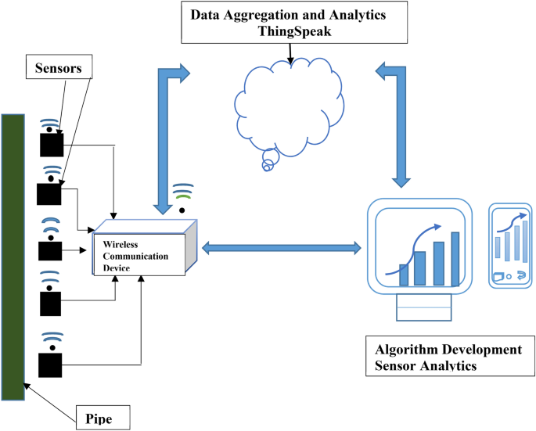

The Deliverable shall include the architectural diagram as below and the information as per the table1 & table 2

**Example: Or Order processing during pandemics for offline mode**

**Table-1 : Components & Technologies:**

|  |  |  |  |
| --- | --- | --- | --- |
| **S.No** | **Component** | **Description** | **Technology** |
|  | sensors | a device that detects and responds to some type of input from the physical environment. | HTML, CSS, JavaScript / Angular Js / React Js etc. |
|  | Wireless communicatin device | the transmission of voice and data without cable or wires | Java / Python |
|  | pipe | a tube with a small bowl at one end that is used for smoking tobacco | IBM Watson STT service |
|  | Data aggregation and analytics thing speak | **aggregate data** to a lower time resolution in a **ThingSpeak**™ channel to remove irregularity. Irregularity in a **data** can be caused ... | IBM Watson Assistant |
|  | Algorithm development sensors analytics | The proposed real-time analysis algorithm delivers a **reliable notification system** that allows bridge managers to track unexpected events as a basis | MySQL, NoSQL, etc. |
|  |  |  |  |
|  |  |  |  |
|  |  |  |  |
|  |  |  |  |
|  |  |  |  |
|  |  |  |  |

**Table-2: Application Characteristics:**

| **S.No** | **Characteristics** | **Description** | **Technology** |
| --- | --- | --- | --- |
|  | Open-Source Frameworks | List the open-source frameworks used | Technology of Opensource framework |
|  | Security Implementations | List all the security / access controls implemented, use of firewalls etc. | e.g. SHA-256, Encryptions, IAM Controls, OWASP etc. |
|  | Scalable Architecture | Justify the scalability of architecture (3 – tier, Micro-services) | Technology used |
|  | Availability | Justify the availability of application (e.g. use of load balancers, distributed servers etc.) | Technology used |
|  | Performance | Design consideration for the performance of the application (number of requests per sec, use of Cache, use of CDN’s) etc. | Technology used |